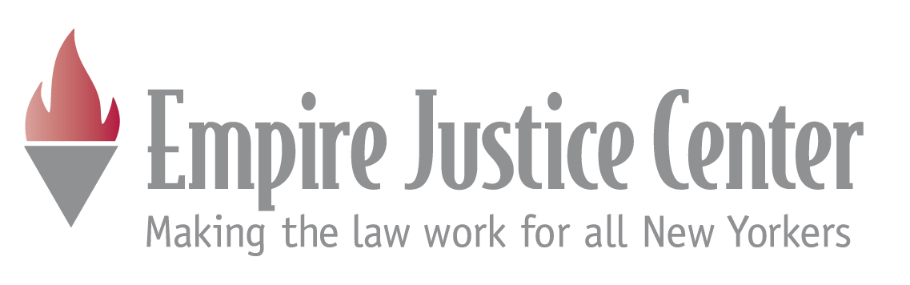

The Impact of Federal Health Care Reform
on New York’s Medicaid Program

By Trilby de Jung
Senior Health Law Attorney
Empire Justice Center

January 4, 2010

- BACKGROUND ON FEDERAL MEDICAID

42 U.S.C. § 1396 et seq., 42 C.F.R. § 430 et seq.

  - Medicaid was created under federal law as a joint, federal-state entitlement program. Individuals have a legal right to payment for covered services that are medically necessary. Also, states have a legal right to federal contributions to state expenditures.

  - States are required to provide certain minimum services to certain populations specified as mandatory. The program’s designation of “deserving poor” (children, parents and caretakers, elderly and disabled persons) as mandatory populations deserving of more favorable treatment (financial eligibility) is a result of historical connection to welfare. This is referred to as “categorical eligibility.”

  - States are required to describe their Medicaid programs in formal state plans, which must be submitted to the federal Center for Medicare and Medicaid Services (CMS) for approval.

  - Federal law does allow states to experiment with new and different ways of structuring health care services for the low-income by proposing waivers to CMS for approval.

- KEY CHANGES TO MEDICAID IN FEDERAL HEALTH CARE REFORM LEGISLATION

  - Expansion -- Medicaid is envisioned as one of three legs supporting universal coverage (other two are employer coverage and the Exchange). Both bills create a massive expansion of the program on the national level. Estimates from the Congressional Budget Office are that the House bill adds 15 M to Medicaid rolls nationally (by raising eligibility levels to 150% of the FPL); the Senate bill adds 11 M (by raising the eligibility level to 133% of FPL).

  - Streamlining -- Both bills streamline eligibility processes in Medicaid by doing away with categorical eligibility (except for purposes of computing federal financial assistance). The Senate Bill includes additional streamlining provisions – requiring states to use gross income levels rather than net levels currently in use in most states. Net income involves applying numerous income disregards that vary for different populations. Unfortunately, neither bill tackles the citizenship and identity verification requirements.

  - Protection Against Gaps in Coverage and/or Services – The Senate bill does more to minimize gaps in coverage during implementation of reforms, both by preserving Child Health Plus and granting states a much larger role in coordinating Medicaid enrollment with the new Exchanges.

The Senate bill puts the states in charge of creating and administering the new Exchanges whereas the House bill would create a national Exchange and establish a Memorandum of Understanding to coordinate enrollment of individuals in Medicaid and Exchange-participating health plans.

The Senate bill also provides grant funding for state offices of health insurance consumer assistance – an ombudsman like program that would advocate for people with private coverage in the individual and small group markets. Such a resource could be very valuable to low-income individuals and families with fluctuations in income that lead to transitions between public programs and private coverage with affordability credits.

  - Selected Public Program Provisions in Health Reform Proposals

Senate Bill: Patient Protection and Affordable Care Act, H.R. 3590
House Bill: Affordable Health Care for America Act, H.R. 3962

HOUSE BILL | SENATE BILL
Expands Medicaid to 150% of FPL – effective 2013 (§1701) | Expands Medicaid to 133% of FPL – effective 2011-2014 (§§ 2001, 2002)
Retains net income test | Gross income test for most(§§ 2001, 2002)
No asset test for most – 2013 [§1703(b)] | No asset test for most – 2014 (§§ 2001, 2002)
Requires coverage for newborns (§305) | Requires premium assistance where cost-effective (§2003)
Allows family planning to non-pregnant women (§1714) | Allows coverage of childless adults up to 200% of FPL [§2001(e)]
Allows coverage for HIV+ at disabled levels (w increased FMAP)(§1731) | Allows creation of Basic Health Plan for uninsured between 133-200% of FPL (§1331)
Eliminates CHP by 2014 – kids between 100-150% of FPL go to Medicaid [§1703(d)]
FMAP at 100% for all new childless adults (even those now covered in waiver), decreasing to 91% beginning in 2015. Also increase in FMAP for newly eligible categorical populations. (§1701) | FMAP at 100% for newly eligible adults (not those currently under waiver). In 2017 shifts to percentage increase, ranging from 30-34%. (§§ 2001, 2002)
Reduced Medicaid DSH funding by $10B by 2019 with the largest reductions in states with lowest uninsured rates [§1704(d)] | Reduces Medicaid DSH funding by 50 or 25%, depending on current DSH funding (§2551)
States must maintain eligibility standards, methodologies and procedures in effect on 6/16/09 (§1703) | States must maintain eligibility standards, methodologies and procedures in effect on the date of enactment of health reform – obligation runs until 2019 [2001(b)]
Eliminates cost sharing for preventive services (§1711) | Encourages the elimination of cost sharing for preventive services with a 1% increase in FMAP (§4106)

- THE EFFECT IN NEW YORK STATE

  - Expansion: Neither bill is likely to result in massive expansion of NYS Medicaid. NYS already covers more than 4.4 M people with its Medicaid-related programs. Only single adults and childless couples are below the income expansion levels in the federal legislation, so federal health care reform will not create large numbers of newly eligible people in NY. The House bill would sunset federal funding for the CHP program at the end of 2013.

NY does not currently provide coverage to HIV+ people at the income levels applicable to those with disabilities (AIDS), so this option in the House bill would create some expansion (would sunset in 2013). Also, House bill offers states the option of incremental expansion in eligibility for family planning service (accomplished by a budgeting rule that would count only the income of the person applying).

Whether federal reform will enhance NYS’s ability to enroll eligible uninsured individuals depends in large part on two things: will the reforms result in more streamlined eligibility processes, and will there be attention and financial support for coordination of coverage – particularly during initial implementation of the new Exchanges.

    - Streamlining: Most of the streamlining reforms in the bills are already in place in NY.

NYS has taken significant steps to streamline Medicaid eligibility processes in recent years. The resource test was eliminated for most applicants in January (currently have federal approval of this reform for the Family Health Plus program – as of January 8, 2010, the state had was still waiting for federal approval for the change in the Medicaid program).

NYS will also be eliminating the requirement for face to face interviews, effective April 1, 2010. We have received federal approval to implement 12 month continuous eligibility for adults as well as children. We have also begun to reduce categorical eligibility distinctions by collapsing age distinctions between children and removing some of the welfare related restrictions on eligibility that were applied to single adults and childless couples in Medicaid.

NYS has not yet implemented a gross income test, which could significantly reduce the time devoted to eligibility determinations in county offices (the budgeting process).

    - NYS Would Not Qualify for Enhanced Federal Assistance Under the Senate Bill.

Under the Senate bill, NYS is penalized for being out front with coverage expansions. Under the House bill, all states would receive 100% federal funding for coverage expansion through 2014, with 91% federal funding thereafter, even when the expansions have already been covered under a waiver. Under the Senate bill enhanced federal funding would only be available only for populations that are newly eligible (100% for 2014-2016, approximately a 33% increase in the FMAP formula thereafter).

Both bills reduce another source of Medicaid funding that is critically important in NYS – Disproportionate Share Funding or DSH. Some number crunching is necessary to get a detailed picture, but analysts say again, NY fares much better under the House bill.

  - Federal reform may actually result in restrictions on current access to health care for low-income New Yorkers currently covered by public health insurance programs.

The House bill would sunset federal funding for the CHP program at the end of 2013. Some children currently eligible for CHP would be eligible for affordability credits in the new Exchanges. Coverage in the Exchange will not be as comprehensive or affordable as NYS’s current CHP program.

NYS will also see cuts to Medicaid funding for Disproportionate Share Hospitals, which will undoubtedly impact the state’s ability to retain a strong network of Medicaid providers.

In addition, unless NYS receives enhanced federal funding for Medicaid as a result of federal reform, the Department of Health may backtrack on potential coverage expansions, particularly in the FHP program. The Governor will undoubtedly face political criticism for some of the Medicaid reforms already implemented and could see some back tracking in streamlining and/or eligibility levels.

Maintenance of effort provisions will be important in the federal legislation. Although the federal reform bills also provide minimum benefit packages in Medicaid, leave room for service cuts in NYS.
The House bill requires states to maintain eligibility standards, methodologies and procedures in effect on June 16, 2009. The Senate bill requires states to maintain eligibility standards, methodologies and procedures in effect of the date of enactment of health reform, until 2019.

